Lab – Using Windows PowerShell
By: Sean Patterson
Part 1: Access PowerShell console.
- Click Start. Search and select PowerShell.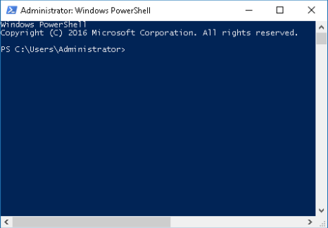
- Click Start. Search and select Command Prompt.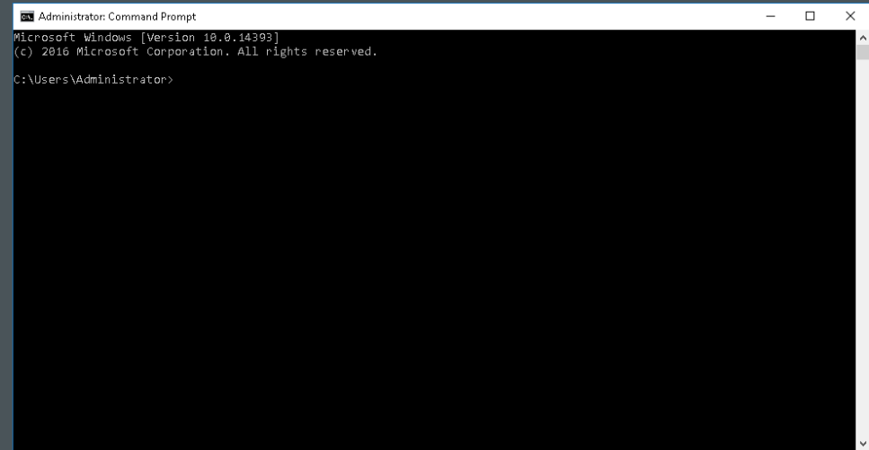

Part 2: Explore Command Prompt and PowerShell commands.
- Enter dir at the prompt in both windows. What are the outputs to the dir outputs?
  - The outputs for both windows is the directories that are in the C:\Users\Administrator.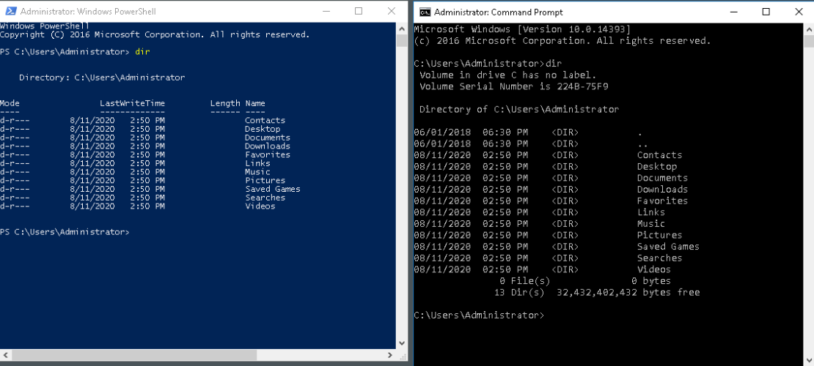
  - Try another command that you have used in the command prompt, such as ping, cd, and ipconfig. What are the results?
    - The results of using other commands in both are the same outputs.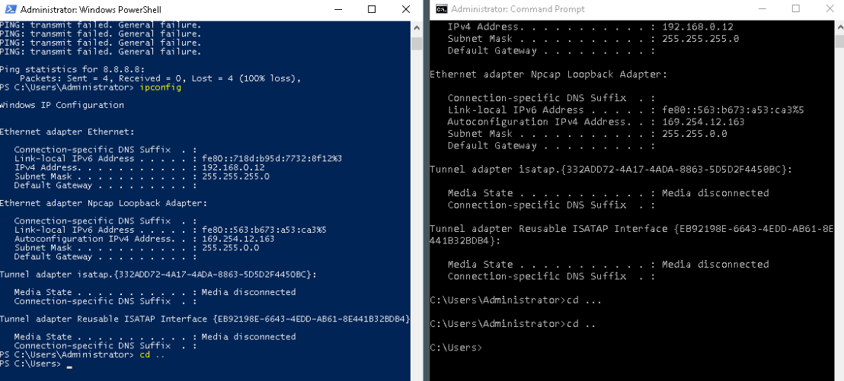
Part 3: Explore cmdlets
- PowerShell commands, cmdlets, are constructed in the form of verb-noun string. To identify the PowerShell command to list the subdirectories and files in a directory, enter Get-Alias dir at the PowerShell prompt. What is the PowerShell command for dir?
  - The PowerShell command for dir is Get-ChildItem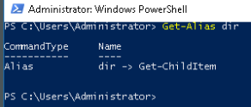
Part 4: Explore the netstat command using PowerShell
- At the PowerShell prompt, enter netstat -h to see the options available for the netstat command.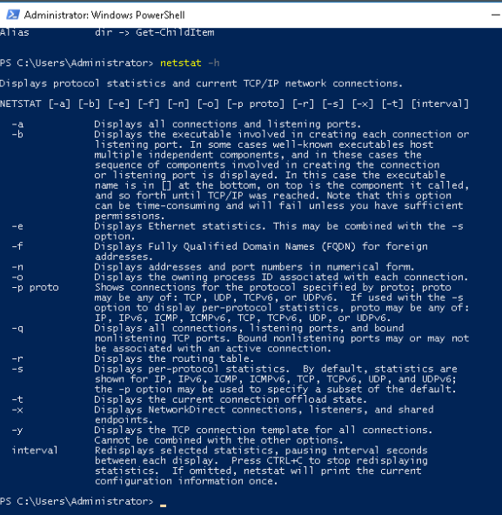
- To display the routing table with the active routes, enter netstat -r at the prompt. What is the IPv4 address?
  - The IPv4 gateway is On-Link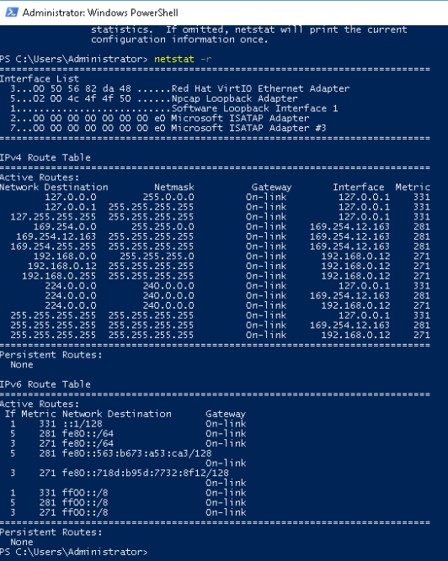
- Open and run a second PowerShell with elevated privileges. Click Start. Search for PowerShell and right-click Windows PowerShell and select Run as administrator. Click Yes to allow this app to make changes to your device.
- To netstat command can also display the processes associated with the active TCP connections. Enter the netstat -abno at the prompt.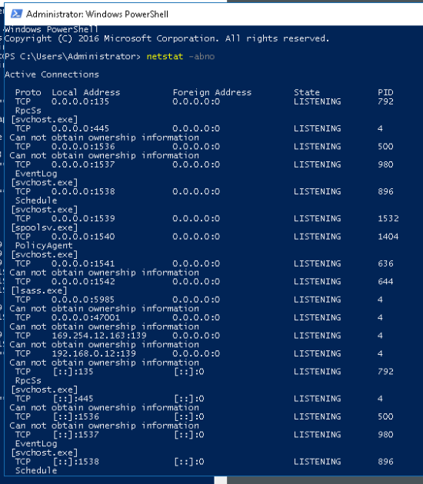
- Open the Task Manager. Navigate to the Details tab. Click the PID heading so the PID are in order. 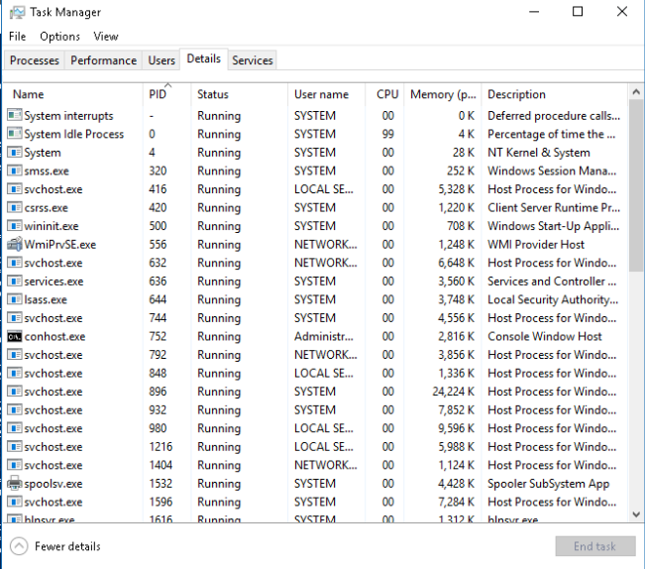
- Select one of the PIDs from the results of netstat -abno. PID 756 is used in this example.
- Locate the selected PID in the Task Manager. Right-click the selected PID in the Task Manager to open the Properties dialog box for more information. What information can you get from the Details tab and the Properties dialog box for your selected PID?
  - You can get the size, the Type, Date modified, file description of that current running TCP connection. 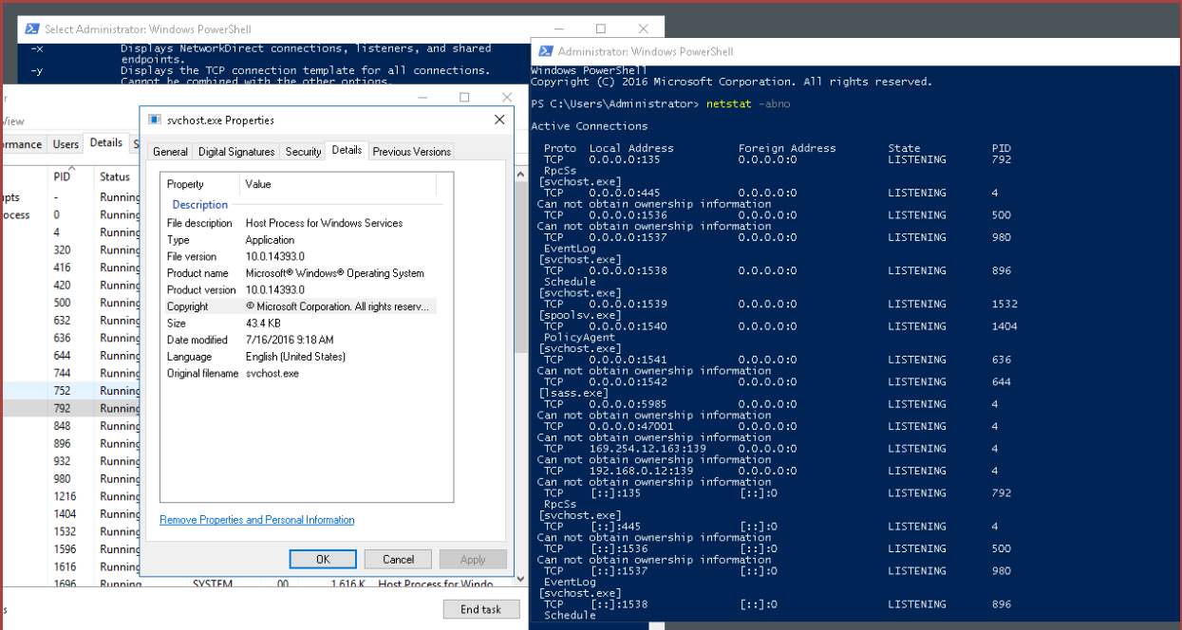
Part 5: Empty recycle bin using PowerShell
- Open the Recycle Bin. Verify that there are items that can be deleted permanently from your PC. If not, restore those files.
- If there are no files in the Recycle Bin, create a few files, such as text file using Notepad, and place them into the Recycle Bin. 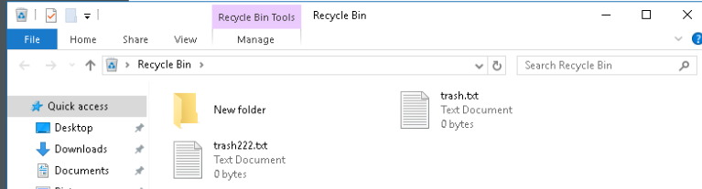
- In PowerShell console, enter clear-recyclebin at the prompt. What happened to the files in the Recycle Bin?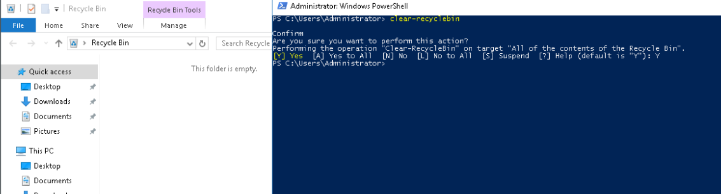

Reflection Questions
- PowerShell was developed for task automation and configuration management. Using the Internet, research commands that you could use to simplify your tasks as a security analyst. Record your findings.
  - Some commands that a Security Analyst could use to simplify tasks in everyday life are:
    - Get-Process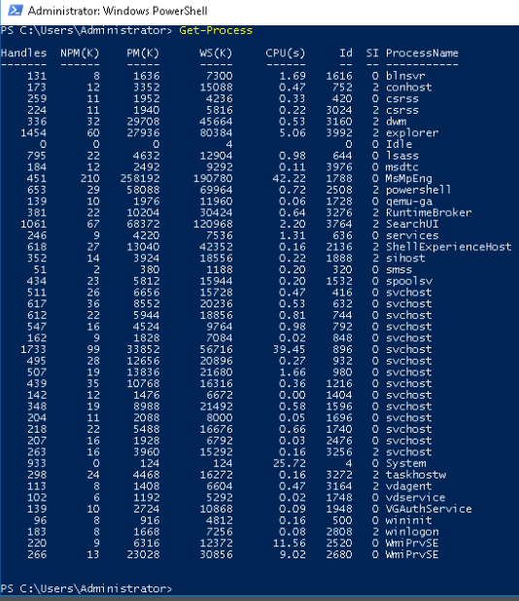
    - Get-Service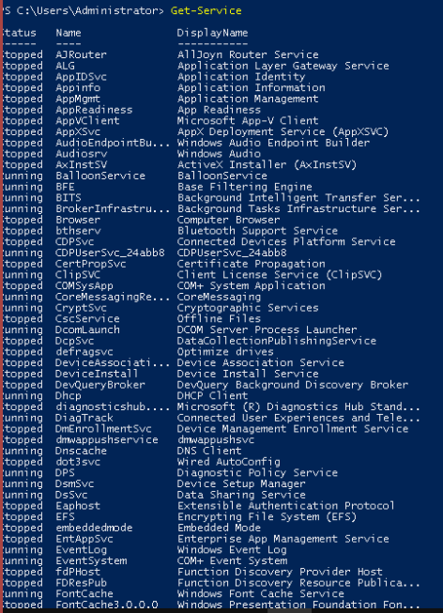
    - Get-NetTCPConnection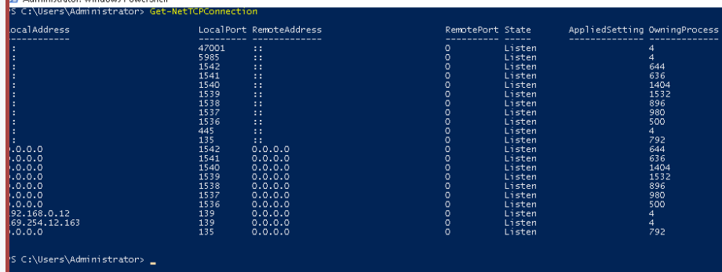
    - Get-LocalUse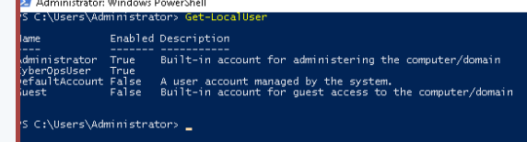
    - Get-WinEvent -LogName Security -MaxEvents 100